Casual Volunteer Opportunities

Community Action Days

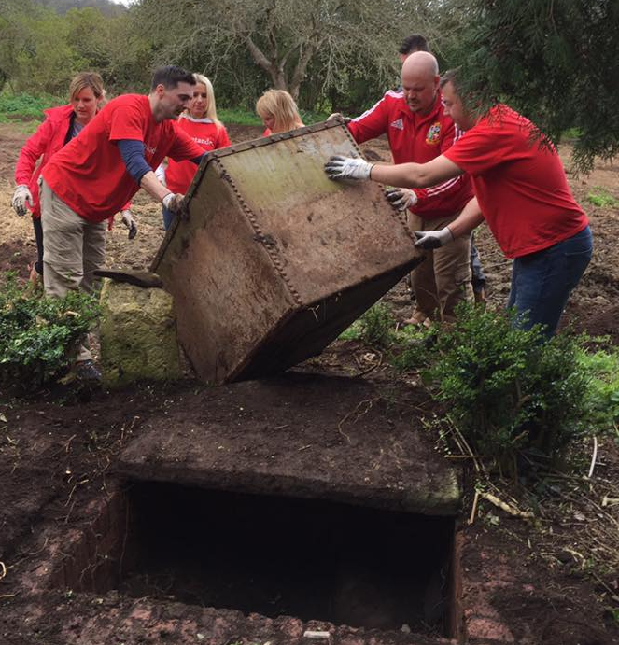
There’s currently a lot happening down on the Farm, with a new visitors’ area, upcycled furniture shop, and cafe on the horizon, we have big dreams to turn into reality.

With so much to do, local people get together to have fun and give back. From giving one of our old offices a fresh coat of paint to moving Polytunnels, there is wide variety of jobs we do.

To register your interest please contact gaby.oliva@brandontrust.org and you will be contacted when we are running a Community Action Day.

Help our stalls in St Nick’s Farmers Market or Fishpond’s Craft and Farmers Market
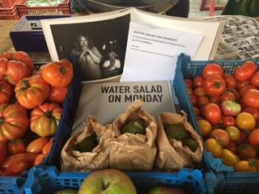
Every Wednesday 9.30am-1.30pm, we sell produce at our Bristol Farmers’ Market stall in St Nick’s. Our stall is at the top of Corn Street by the junction with Broad Street.

Every last Saturday of the month we have a stall at Fishpond’s Craft and Farmers Market, in The Old Library, Fishponds Road.

To apply, please return our registration form to gaby.oliva@brandontrust.org Gaby Oliva, Elm Tree Farm, Park Road, Stapleton BS16 1AA.

Events

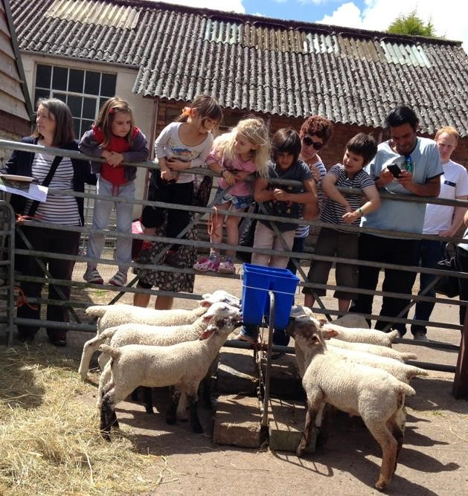
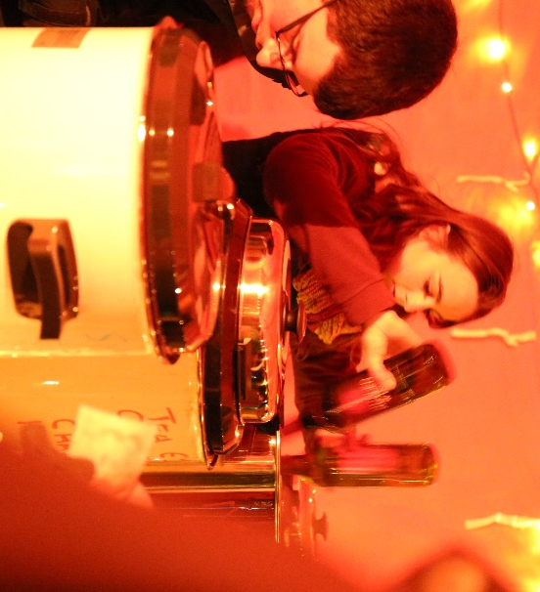
Volunteers are essential to make our community events enjoyable and fun. Depending on the event there are variety of ways to help. You could be helping to serve food, running a kid’s crafts stall, playing music or stewarding.

To register your interest please contact gaby.oliva@brandontrust.org and you will be contacted when we are running an event.

Fundraise for us

Help us achieve our goals by fundraising for us. Community groups have fundraised in all sorts of ways from craft fairs, knit-a-thons to a community May Day event.
