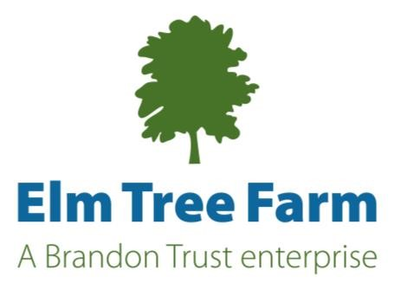
Farm worker volunteer opportunities

Farm Buddy for people with learning disabilities
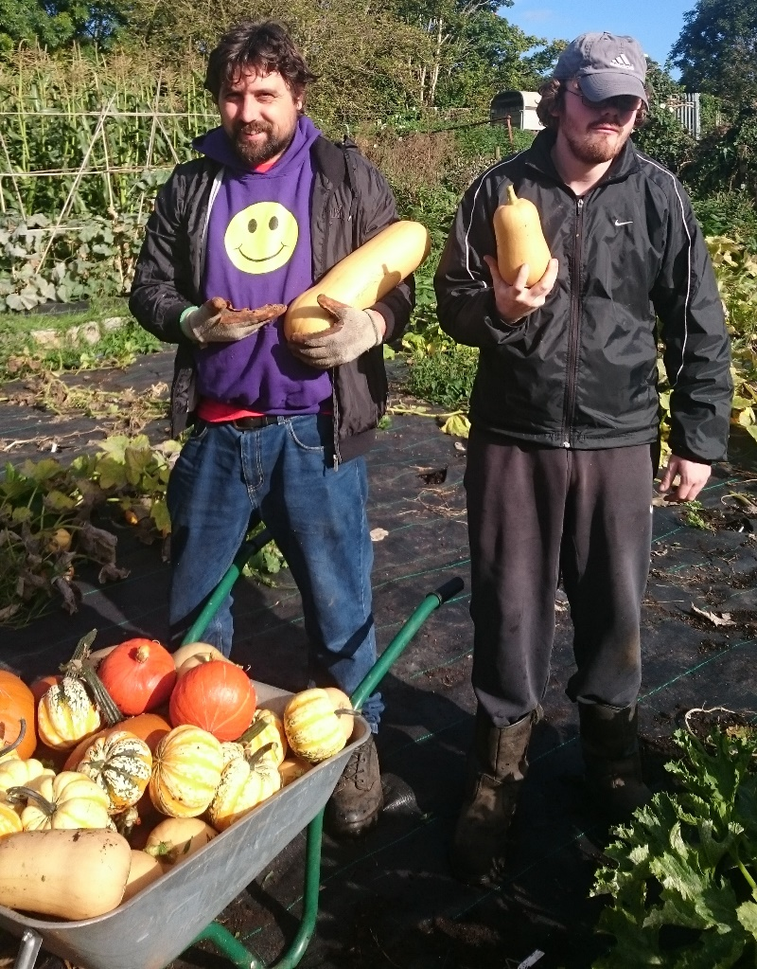
As a Farm Buddy, you may be supporting someone to groom our Shetland pony, cook spicy squash chutney or upcycle a wardrobe.

You will build rewarding relationships with people, as you help someone stay focused, work hard and flourish at animal care, growing food, gardening or woodwork.

Volunteering with the people we support will be a rewarding experience, as you will see someone grow in independence, gain confidence, identify hidden skills and reach their full potential.

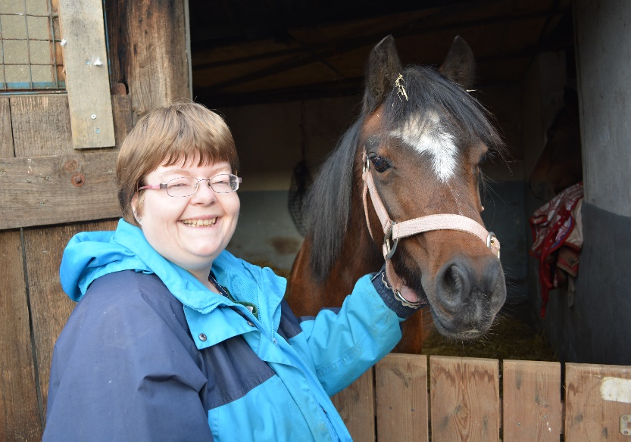
3 hours per week minimum, Monday-Friday,8.30am-3pm, 3 months commitment. Reference and basic DBS required.
To apply, please return our registration form to gaby.oliva@brandontrust.org Gaby Oliva, Elm Tree Farm, Park Road, Stapleton BS16 1AA.

Animal care

Want to learn about and help look after our ponies, pig, lambs, ducks, cows, rabbits and hens?

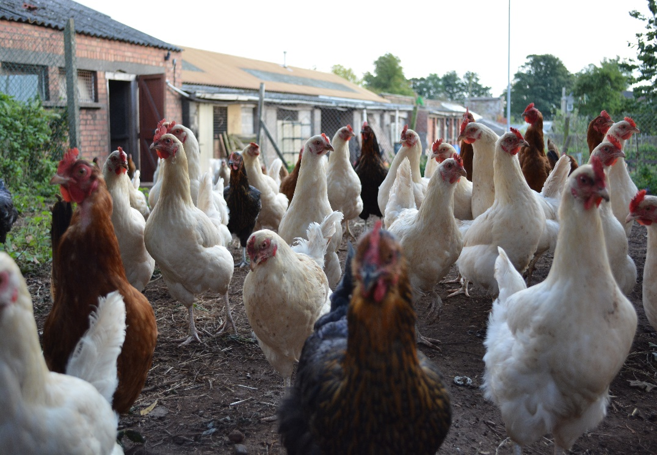
In this role, you will gain an insight of farming and animal care for a small holding.

From mucking out to repairing fencing, you will experience the wide-range of activities involved in animal care. With initial training, you will develop initiative and work independently.

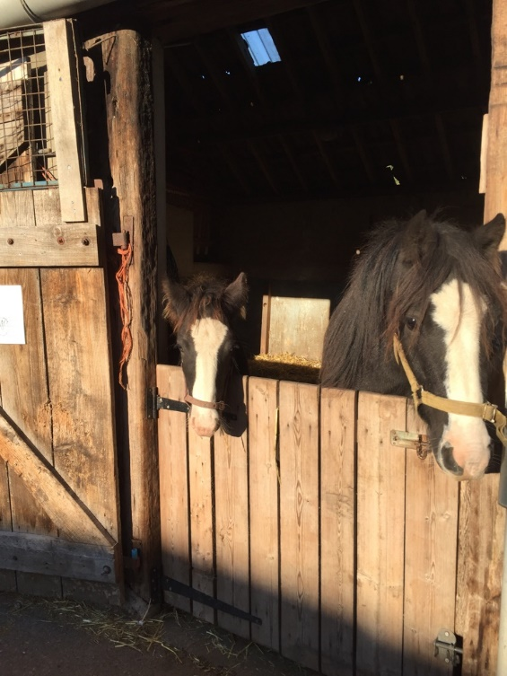
We are particularly interested in people with experience of working with animals in a farm or small holding environment. It is essential you are prepared to work in all weathers.

3 hours minimum at a regular time Monday-Friday,8.30am-3pm or weekends. 3 months commitment. Reference and basic DBS required.

To apply, please return our registration form to gaby.oliva@brandontrust.org Gaby Oliva, Elm Tree Farm, Park Road, Stapleton BS16 1AA.

Farm Shop Volunteer & Supported Volunteering

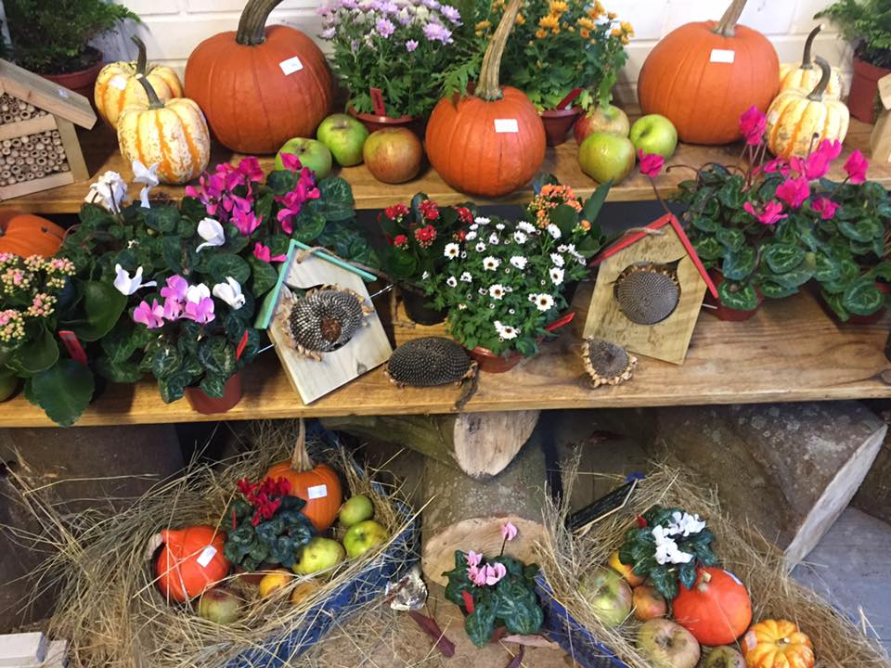
Our farm shop is the front face of our social enterprise. All the products made by people we support at Elm Tree Farm are sold in our onsite farm shop. With a new extension for upcycled furniture, our Farm shop is an important milestone for developing our projects as all their hard work contributes to the local economy.
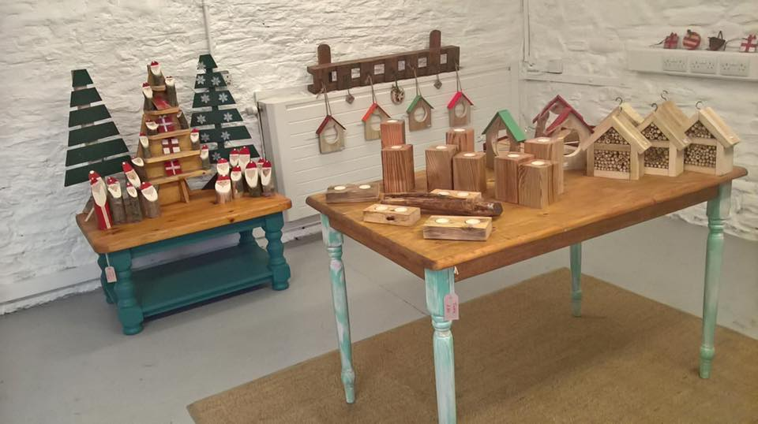
There is opportunity for the role to develop; whether it is building links with other local producers who could stock the shop, creating display information to spread knowledge to our customers or helping trainees use the till and complete the weekly checks.

Volunteers with support needs are welcome to apply, as long as, they can bring their own support.

3 hours minimum at a regular time Monday-Friday,8.30am-3pm or Saturday 9am-12pm. 3 months commitment. Reference and enhanced DBS required.

To apply please return our registration form to gaby.oliva@brandontrust.org Gaby Oliva, Elm Tree Farm, Park Road, Stapleton BS16 1AA.

Growing food in our Market Garden

Would you like to get some fresh air, get your hands dirty and help grow organic vegetables?

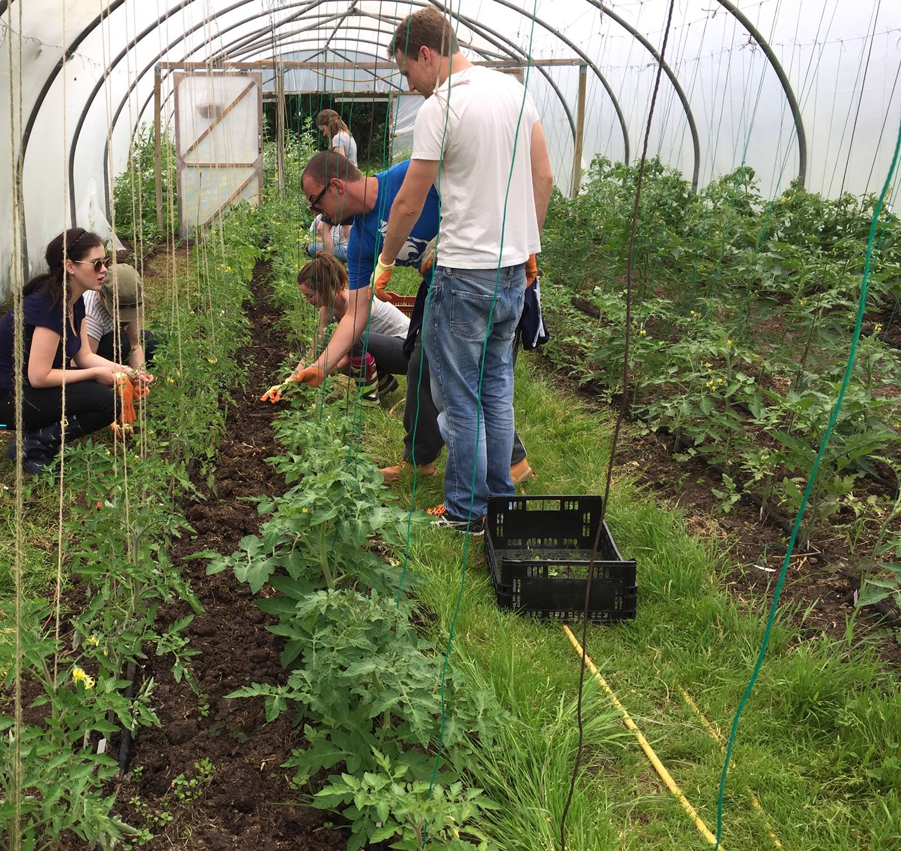
In this role, you will gain an insight of growing food in a vibrant 2-acre plot, on a scale much bigger than your own back garden. You will also find your green fingers as you learn organic methods to produce a wide range of seasonal fruit and vegetables.

We are particularly interested in people with experience of working in market gardens, allotments or other food growing environments. It is essential you are prepared to work in all weathers.

3 hours minimum at a regular time, Monday-Friday,8.30am-3pm, 3 months commitment. Reference and basic DBS required.

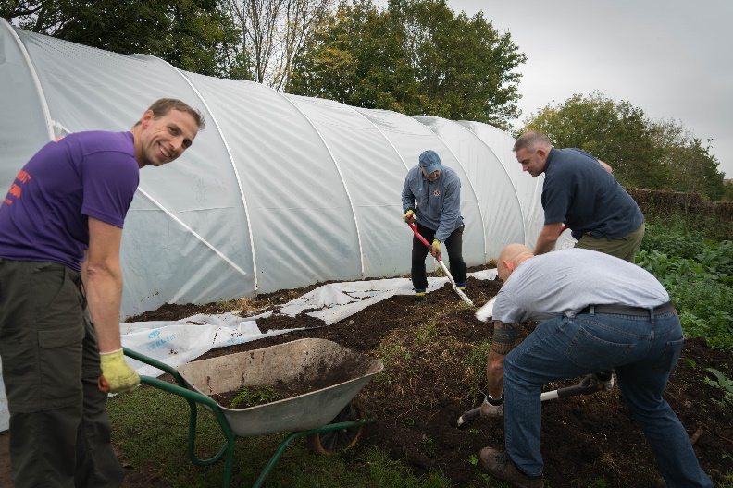
To apply, please return our registration form to gaby.oliva@brandontrust.org Gaby Oliva, Elm Tree Farm, Park Road, Stapleton BS16 1AA.

Holiday club for young people with support needs

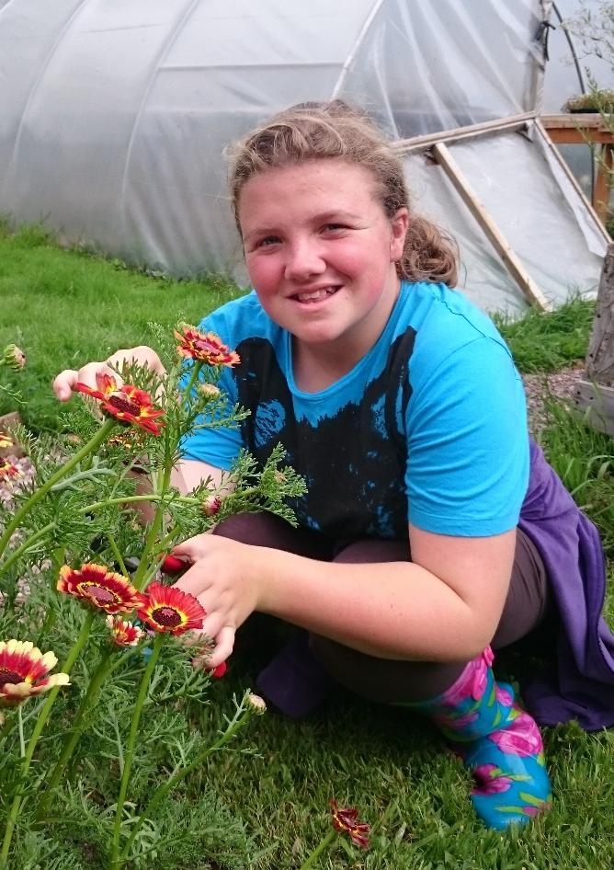
Our holiday club gives young people with support needs an opportunity to try new things, get outdoors and make friends over the school summer holidays.

From tree measuring, egg collecting to making salad, join in with the fun as you support activities based all-round the farm.

3 hours minimum, Monday-Friday,8.30am-3pm. Reference and enhanced DBS required.

To apply, please return our registration form to gaby.oliva@brandontrust.org Gaby Oliva, Elm Tree Farm, Park Road, Stapleton BS16 1AA.

Fundraise for us

Help us achieve our goals by fundraising for us. Community groups have fundraised in all sorts of ways from craft fairs, knit-a-thons to a community May Day event.
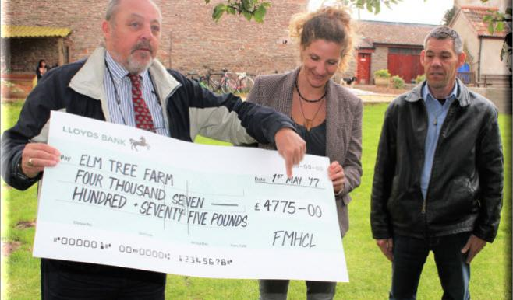

Weekend Growing Coordinator

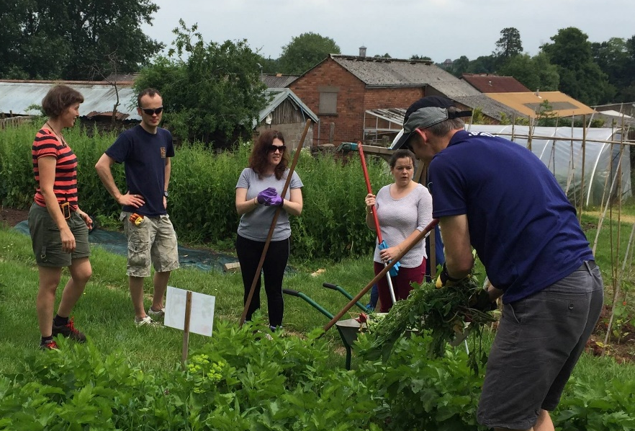
Grow your creativity, horticulture and leadership skills as you take the reins of an exciting and new organic gardening project. We need someone to coordinate growing activities on weekends to prepare the Market Garden for people with learning disabilities and/or autism to work in.

Working alongside a member of staff and other Weekend Growing Coordinators, you will gain project development skills, including recruiting volunteers. You will also develop skills such as leadership, project coordination and initiative.

Experience of working in market gardens, allotments or other food growing environments is essential. 4 hours per week minimum. Growing sessions are intended to run on weekends and the role will require additional time during the week for planning the session and coordinating volunteers. 3 months commitment. Reference and basic DBS required.

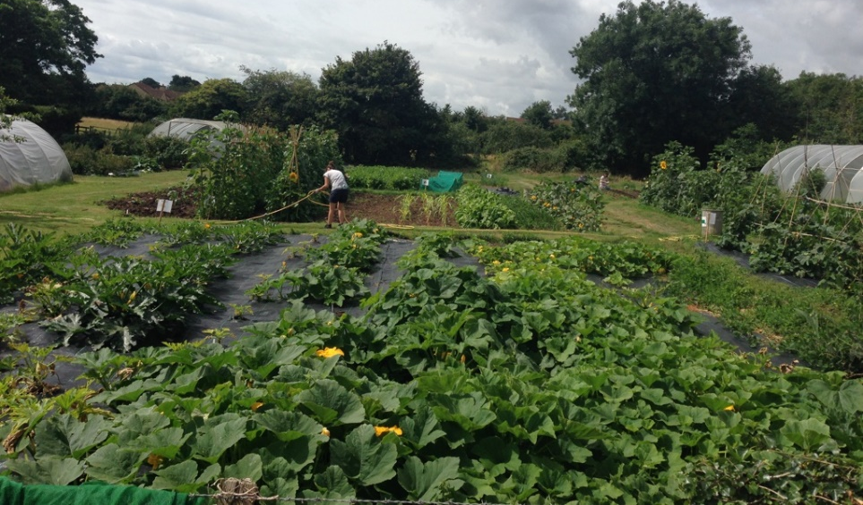
To apply, please return our registration form to gaby.oliva@brandontrust.org Gaby Oliva, Elm Tree Farm, Park Road, Stapleton BS16 1AA.

Make chutneys with farm produce

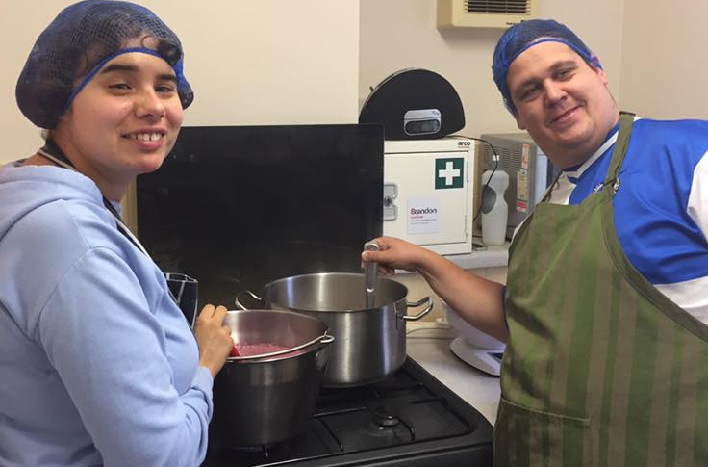
To reduce food waste, we use any unsold stock to make our own chutneys and jams for sale in our farm shop.

We are looking for someone with an interest or experience in making a range of chutneys or jams, who could choose a recipe, prepare ingredients and cook independently.

To apply, please return our registration form to gaby.oliva@brandontrust.org Gaby Oliva, Elm Tree Farm, Park Road, Stapleton BS16 1AA.

Help our stalls in St Nick’s Farmers Market or Fishpond’s Craft and Farmers Market

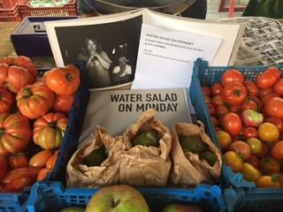
Every Wednesday 9.30am-1.30pm, we sell produce at our Bristol Farmers’ Market stall in St Nick’s. Our stall is at the top of Corn Street by the junction with Broad Street.

Every last Saturday of the month we have a stall at Fishpond’s Craft and Farmers Market, in The Old Library, Fishponds Road.

To apply, please return our registration form to gaby.oliva@brandontrust.org Gaby Oliva, Elm Tree Farm, Park Road, Stapleton BS16 1AA.

